Music Band Website

**Submitted By:**

Rhea Gracy – 2460430 Email: rhea.gracy@btech.christuniversity.in

Jessica Nalini Paully – 2460377 Email: jessica.nalini@btech.christuniversity.in

Angela Elizabeth Domingo – 2462033 Email: angela.elizabeth@btech.christuniversity.in

**Course**: Front End UI/UX Development

**Instructor Name:** Dhiraj Alate

**Institution:** Christ University Kengeri

**Date of Submission**: 12/08/2025

# Abstract

This project aims to design and develop a promotional website for a music band using HTML5 and CSS3. The website showcases the band's profile, members, story, upcoming tour dates, gallery, and contact information. The main goal was to create a visually appealing, structured, and user-friendly interface for fan engagement without the use of JavaScript or server-side scripting. Core technologies used include semantic HTML5 structure and CSS3 styling techniques, including Flexbox and Grid layouts. The final outcome is a functional, static multi-page website that reflects the band's identity, enhances online presence, and offers an engaging platform for visitors.

# Objectives

• Design a visually appealing and user-friendly band website.

• Implement structured HTML5 semantic elements for clarity and accessibility.

• Use CSS3 styling with Flexbox/Grid for layout and alignment.

• Present multimedia content attractively without scripting.

• Ensure design consistency with band-centric branding.

# Scope of the Project

The project focuses entirely on front-end design and development for a static music band website. It includes multiple sections: Hero, About, Tour Dates, Gallery, and Contact. The design is responsive for desktop, tablet, and mobile screens. No JavaScript, backend integration, or external frameworks were used. All visuals and layouts were implemented using HTML5 and CSS3 only.

# Tools & Technologies Used

|  |  |
| --- | --- |
| Tool/Technology | Purpose |
| HTML5 | Markup and content structure |
| CSS3 | Styling and layout management |
| VS Code | Code editor |
| Chrome DevTools | Testing and debugging |

# HTML Structure Overview

The website uses semantic HTML5 elements such as <header>, <nav>, <section>, <table>, and <footer>. Sections include Hero, About, Tour Dates, Gallery, and Contact. Navigation is implemented using an unordered list (<ul>) with anchor links.

# CSS Styling Strategy

An external CSS file (style.css) is used for all styling. The layout uses Flexbox and Grid for arranging elements, media queries for responsiveness, and consistent font and color themes. Hover effects, background images, and typography styling enhance visual appeal.

# Key Features

|  |  |
| --- | --- |
| Feature | Description |
| Responsive Design | Adapts seamlessly to all screen sizes using media queries. |
| Hero Section | Band name with a background image in the top section. |
| Tour Dates Table | Displays upcoming shows in a structured table format. |
| Gallery | Grid-based photo section showcasing band images. |
| Contact Form | Static contact form layout for user interaction. |

# Challenges Faced & Solutions

|  |  |
| --- | --- |
| Challenge | Solution |
| Responsive alignment issues | Applied Flexbox and Grid with proper media queries. |
| Image scaling problems | Used object-fit and responsive units for image dimensions. |
| Consistent color scheme | Created a CSS variables section for theme control. |

# Outcome

The Music Band Website was successfully developed with a clean, visually engaging layout. It meets all project objectives and presents band information in a structured and attractive way. The design adapts well across devices and enhances the band's digital presence.

# Future Enhancements

• Add JavaScript for interactivity (e.g., form validation).

• Include dynamic content like live social media feeds.

• Implement light/dark theme toggle.

• Integrate backend for real contact form submission.

# Sample Code

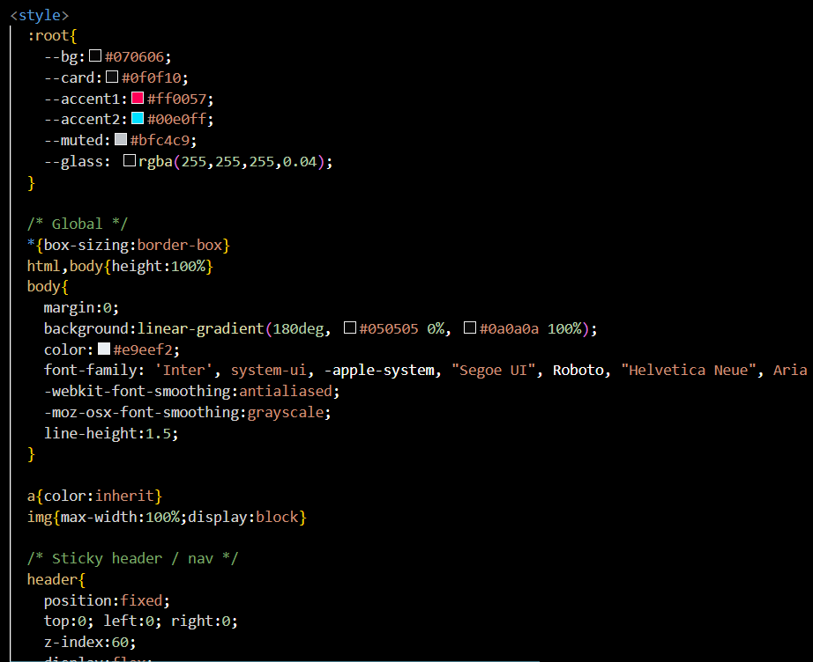

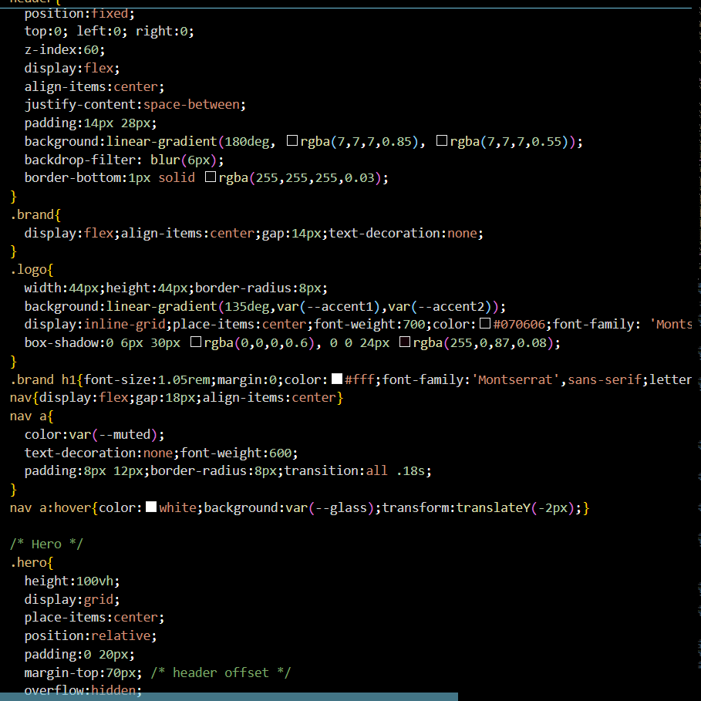

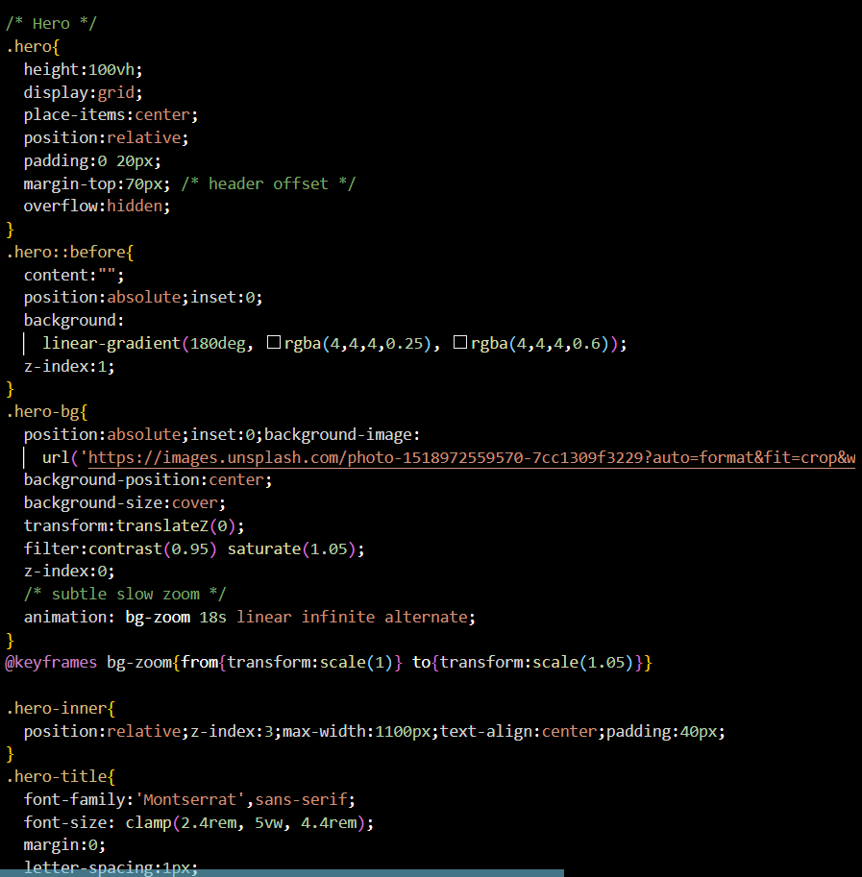

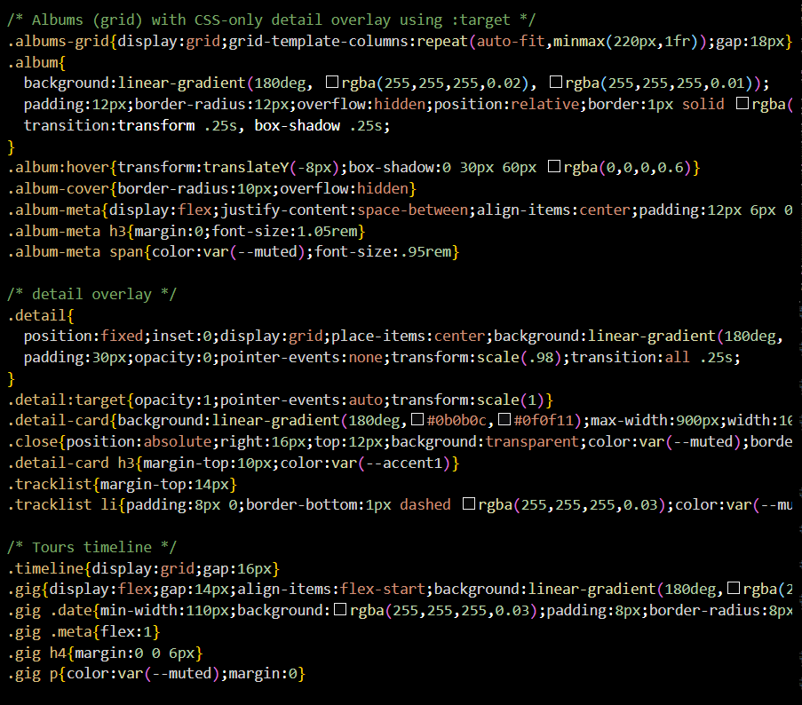

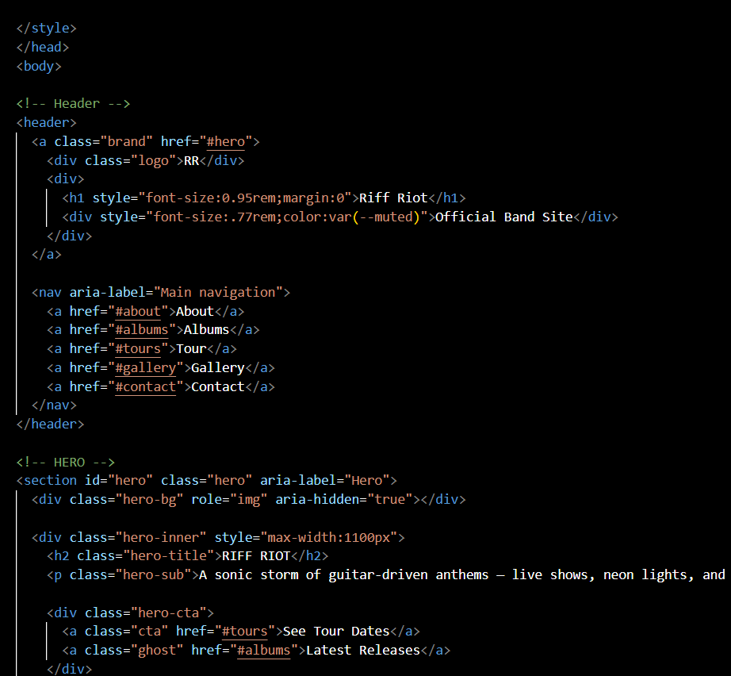

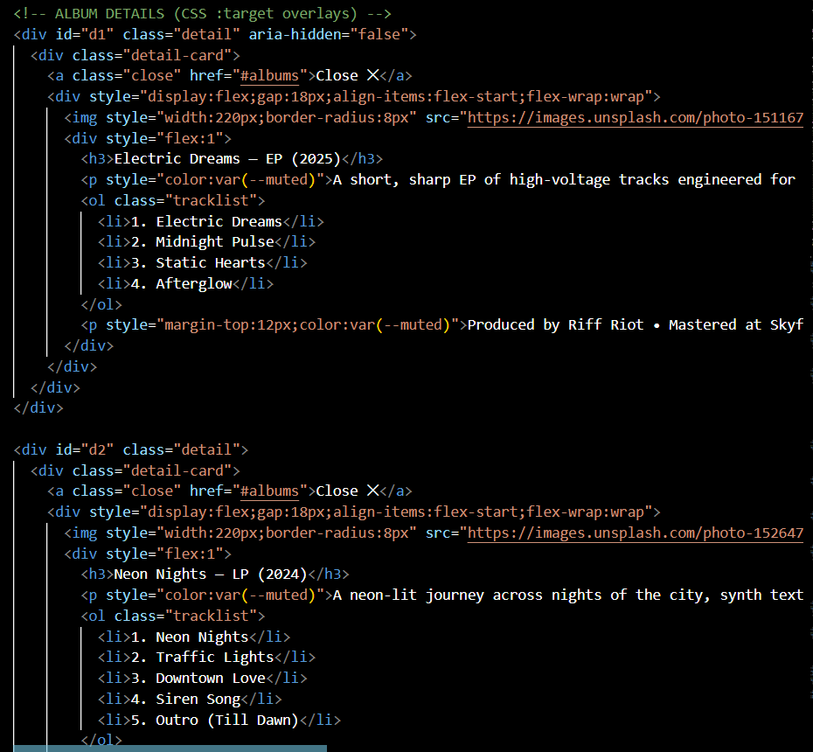

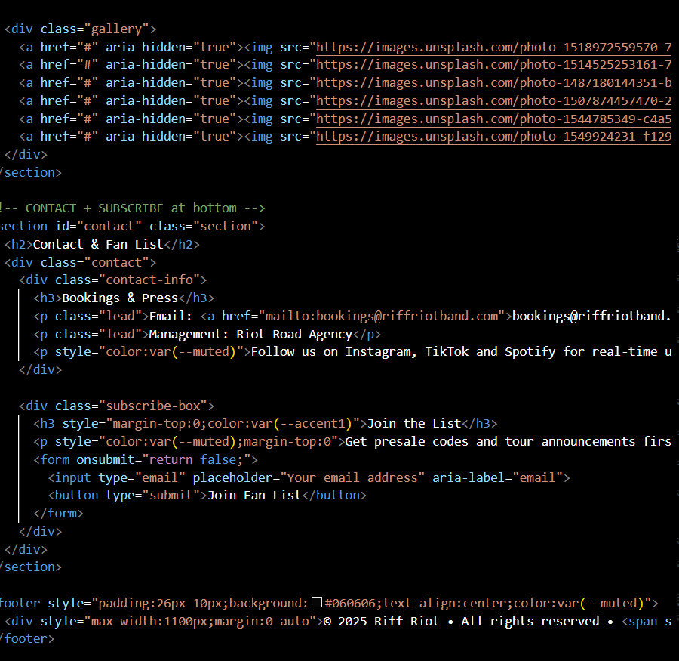

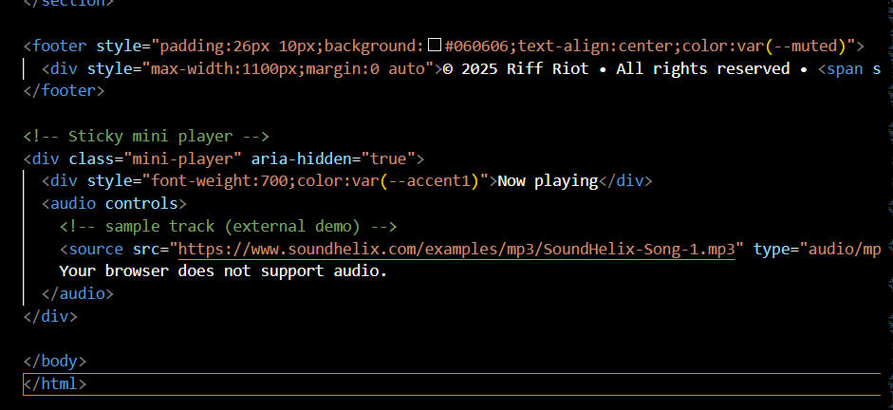

# Screenshots of Final Output

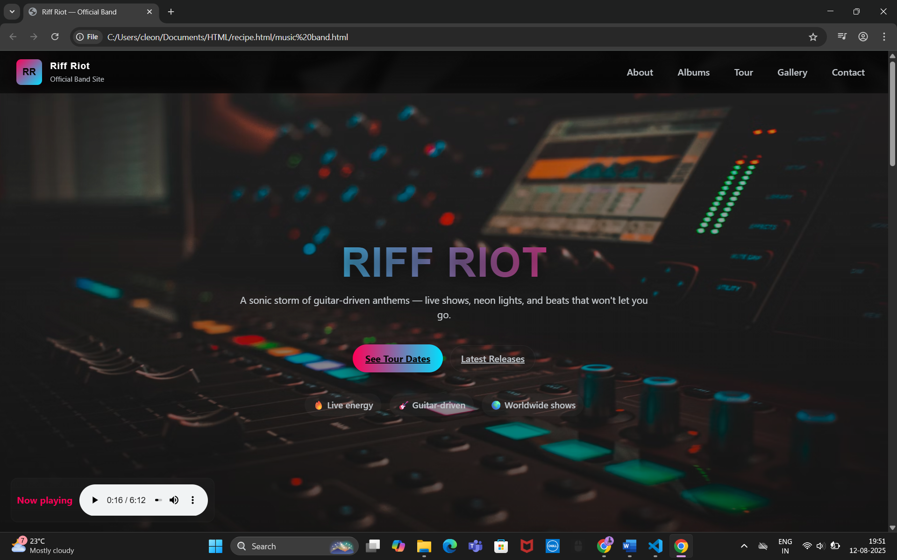

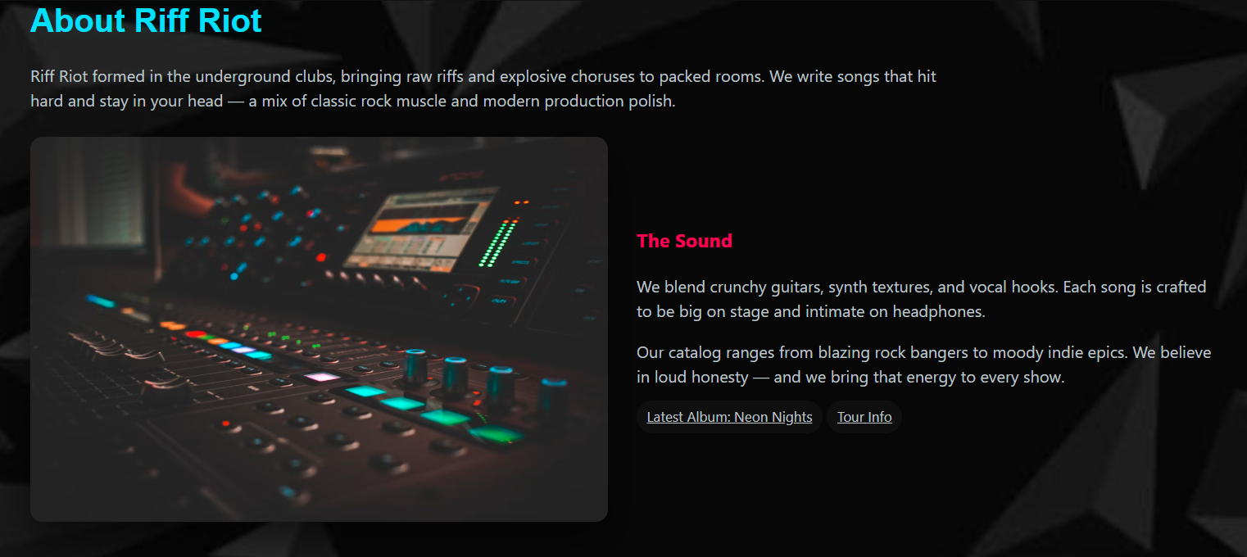

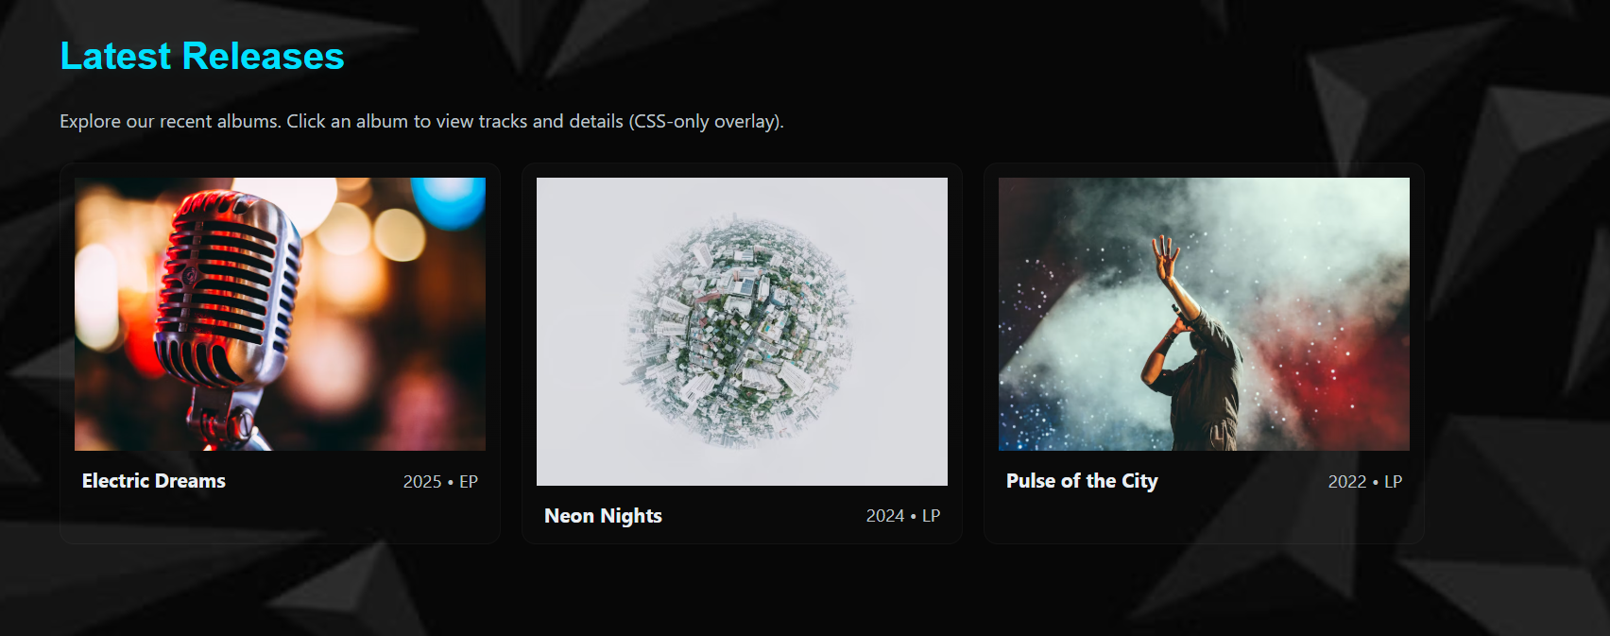

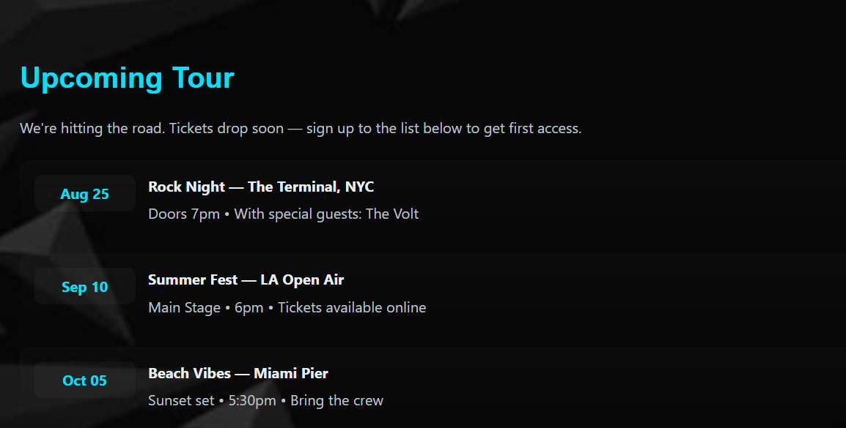

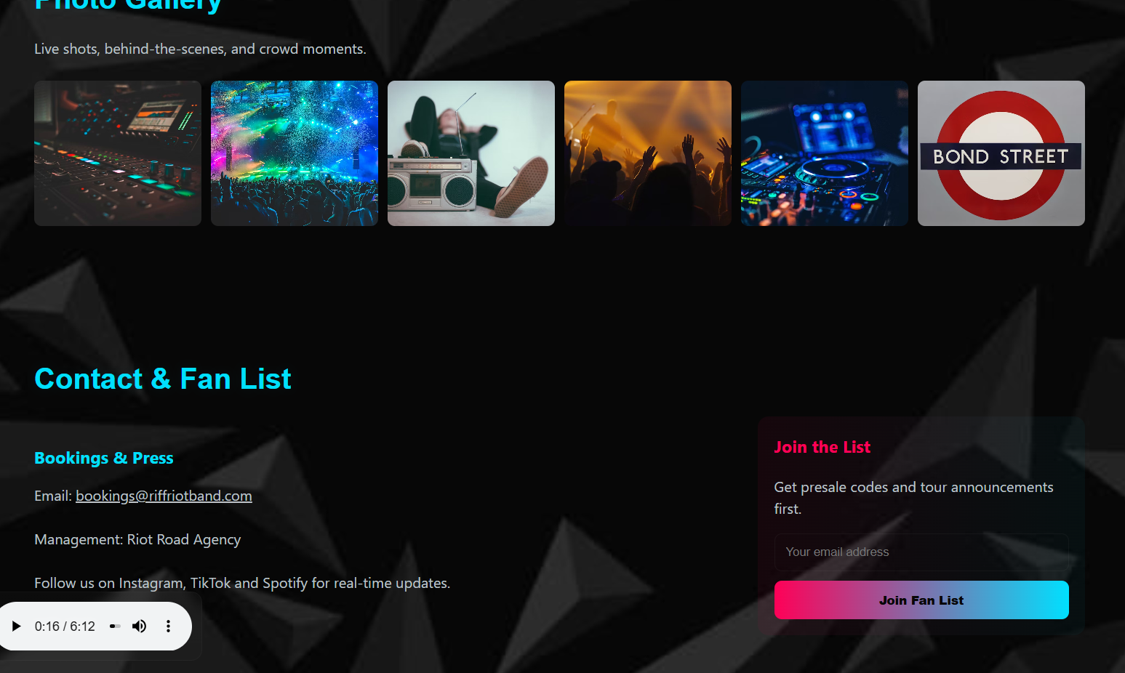

# Conclusion

This Music Band Website project strengthened our skills in HTML5 and CSS3 layout design. We learned practical techniques for responsive design, semantic structure, and consistent branding. The project demonstrated how to create a professional, engaging static website without using JavaScript. The team gained practical experience in layout design, semantic coding, and accessibility principles. This project definitely helped us strengthen our CSS skills and helped us gain practical insights into the design and the layout of this project.

# References

• L&T LMS : https://learn.lntedutech.com/Landing/MyCourse